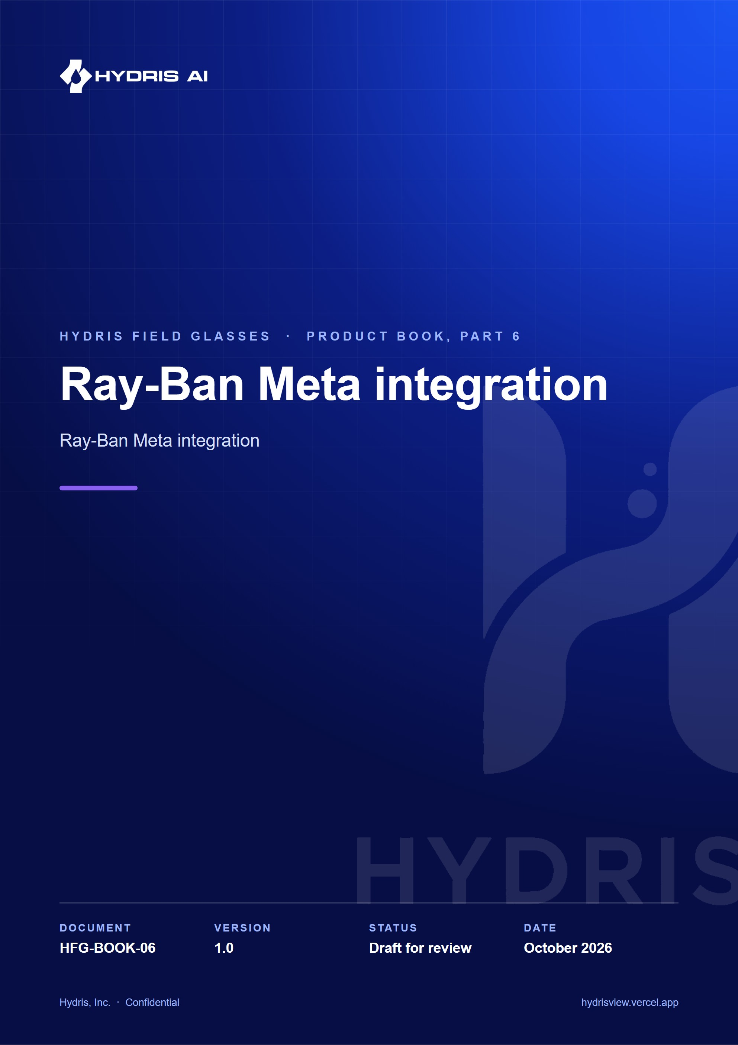
Document control
Document | Ray-Ban Meta integration (HFG-BOOK-06)
Version | 1.0
Status | Draft for review
Owner | Product and engineering, Hydris
Audience | Leadership, product, engineering, design, partners and pilot customers
Product | Hydris Field Glasses: website, operator console, glasses app, Android app, API
Source of truth | docs/product/_part06.md in tarun-km/hydrisview (this Word file is generated from it)
Classification | Confidential: Hydris, Inc. and named partners
Revision history
Version | Date | Author | Changes
1.0 | October 2026 | Product and engineering, Hydris | First edition

Contents
1 Ray-Ban Meta integration 4
1.1 Purpose and problem 4
1.2 Users and jobs 4
1.3 Scope 4
1.4 What the glasses can do 5
1.5 The Meta AI app dependency 5
1.6 DAT lifecycle 5
1.7 Two integration routes 7
1.8 Registering glasses as a Hydris device 8
1.9 Setup guide 9
1.10 Troubleshooting 10
1.11 Requirements 10
1.12 Success metrics 11
1.13 Limitations and publishing constraints 11
1.14 Hardware acceptance status 11

1 Ray-Ban Meta integration

1.1 Purpose and problem
Ray-Ban Meta glasses are the lightest way to give an operator a camera, a microphone and speakers at eye and ear level, but they have no display. Hydris uses them as hands-free sensors for the phone: the glasses camera frames and shoots paper logs, the glasses microphone hears "Hey Hydris", the open-ear speakers play the answer, and the capture button takes the photo. The phone is the screen. The integration uses Meta's Wearables Device Access Toolkit (DAT) 1.0.1 with four modules: core, camera, speech and inputs.
IMPORTANT
No Hydris build has yet been run against physical Meta glasses. All DAT calls compile and are type-checked against DAT 1.0.1, and the page side of the bridge was tested with a stand-in bridge. Every hardware behaviour here is Built, not hardware-verified unless stated otherwise.

4  DAT modules  core, camera, speech, inputs |  | 0  Displays  the phone is the screen |  | 2  Integration routes  native app, WebView bridge |  | 15  Hardware acceptance tests  none run yet

1.2 Users and jobs
Table 1. Users and jobs
User | Job | Requirements
Field operator | Scan a paper log with the glasses camera without holding the phone | FR-055, FR-056
Field operator | Ask by voice and hear the answer on the open-ear speakers | FR-074, FR-077
Supervisor or admin | See the glasses as a managed, revocable device in the console | FR-057
Solutions engineer | Set up and troubleshoot a pilot kit | Setup and troubleshooting below

1.3 Scope
Table 2. Scope
In scope | Out of scope
Ray-Ban Meta Gen 1 and Gen 2 (primary target: Gen 2) | Video recording or upload
Camera preview for guided capture, full-resolution photo | Replacing the Meta AI app
Glasses microphone, phone TTS on the glasses speakers | Hydris UI on the Ray-Ban Meta (it has no display)
Capture button short press | Long press and other gestures
Registering the glasses as a Hydris device | Several pairs of glasses per phone

1.4 What the glasses can do
Table 3. Capability matrix by glasses family
Capability | Ray-Ban Meta | Oakley Meta (HSTN, Vanguard) | Meta Ray-Ban Display
Supported by DAT | Yes (Meta FAQ) | Yes (Meta FAQ) | Yes (Meta FAQ)
Camera stream and photo | Yes | Expected, unverified | Expected, unverified
Microphone through DAT Speech | Yes | Unverified | Unverified
Speakers | Phone TTS over Bluetooth | Phone TTS over Bluetooth | Phone TTS over Bluetooth
Capture button | DAT Inputs | Unverified | Unverified
Display | None | None | Yes; Hydris use Planned
Hydris status | Primary target, not yet on hardware | Untested | Phone path expected; display Planned

Every glasses feature has a phone fallback: phone camera, phone microphone and phone speaker. An operator without glasses loses nothing but the hands-free convenience.

1.5 The Meta AI app dependency
Meta's documentation is explicit that the Meta AI app must be used to pair the glasses. It pairs them to the phone, updates firmware, enables Developer Mode for unpublished apps, and approves each third-party app and each permission (camera, microphone). Hydris does not try to replace it.
DECISION
The Meta AI app must stay installed and signed in. Hydris checks for it (package com.facebook.stella) and, if missing, tells the operator to install it and pair the glasses there first. Hydris pairing is separate: it makes the glasses a managed device in the customer's organization.

1.6 DAT lifecycle
Both Hydris phone apps follow the same lifecycle. DAT is initialized only after Android grants the Bluetooth permissions; the app then watches registration state, connected devices and device names.

Registration and permissions
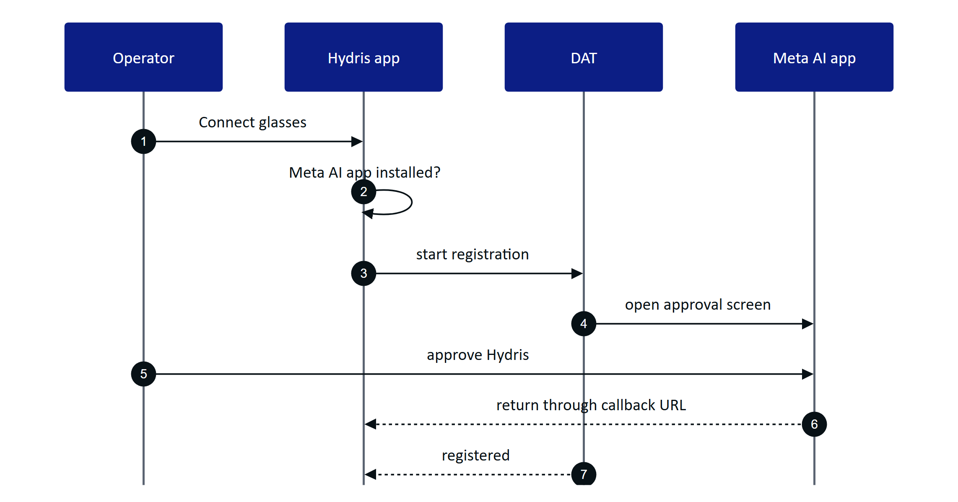
Figure 1. Registration hands off to the Meta AI app and returns
Camera and microphone access on the glasses are DAT permissions, separate from Android permissions, and are also approved in the Meta AI app. Hydris asks for one permission at a time, and a cancelled prompt counts as denied.

Session
One device session is shared by camera, speech and inputs. It is created the first time a capability is needed, reused while started, and rebuilt from scratch after it stops (for example when the glasses are switched off).
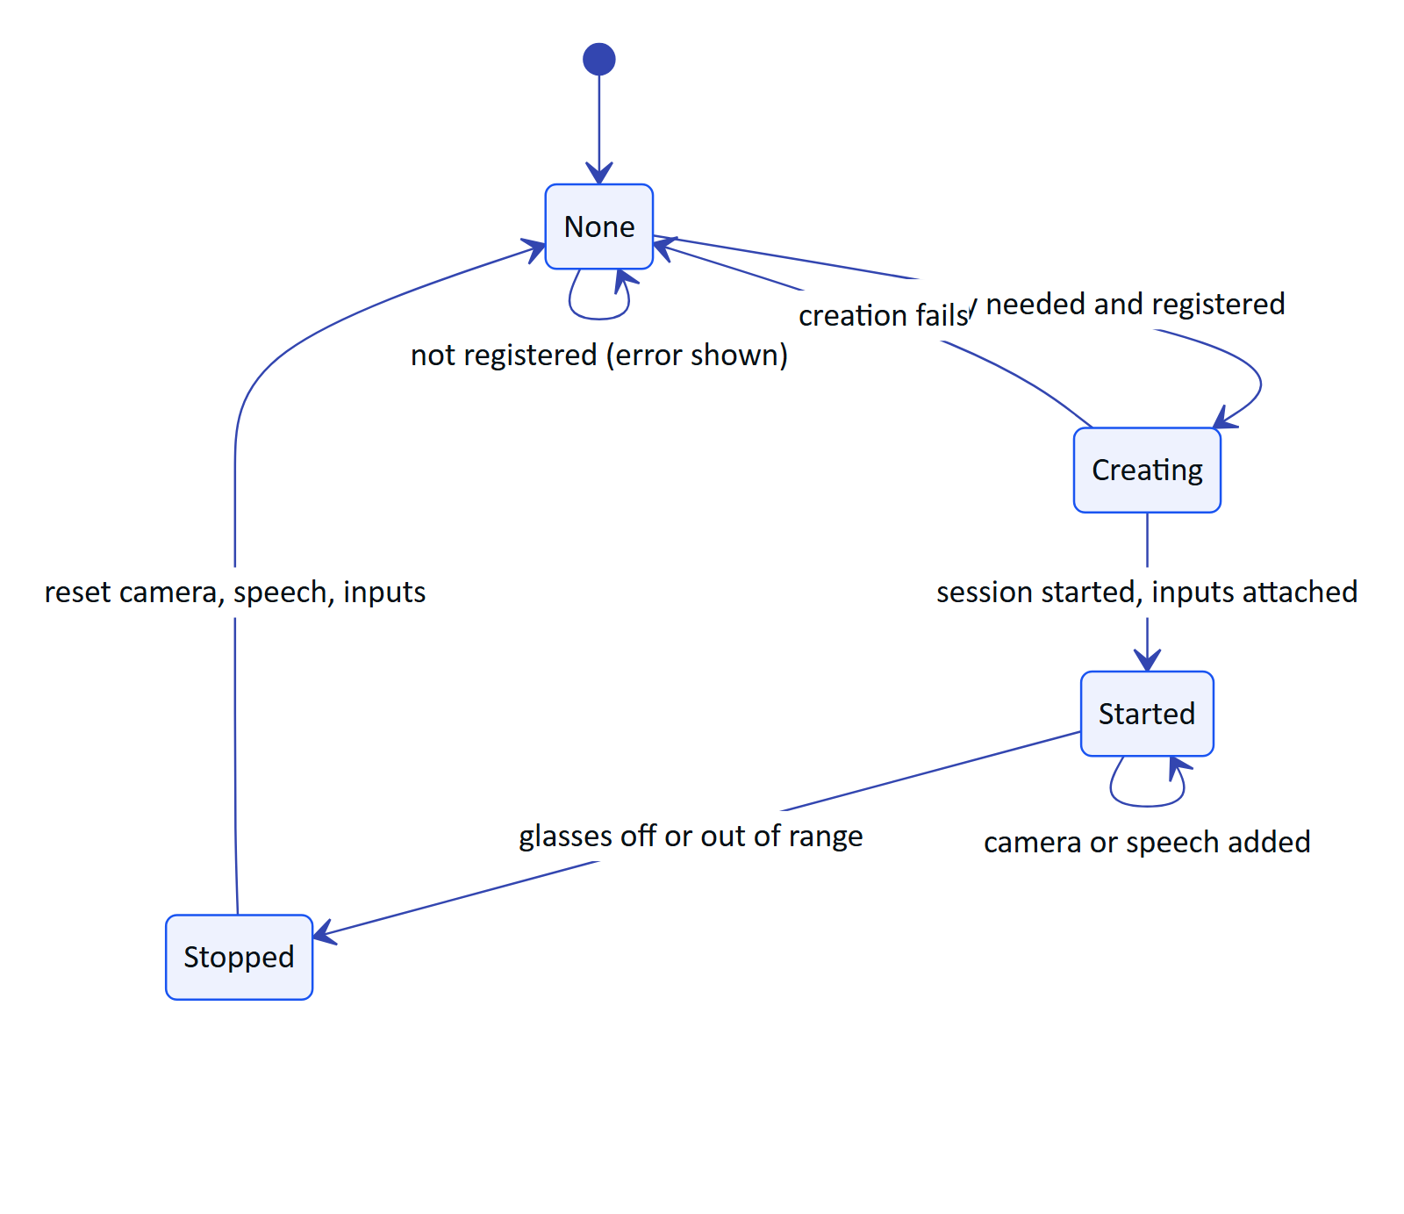
Figure 2. Device session lifecycle

Camera stream and photo
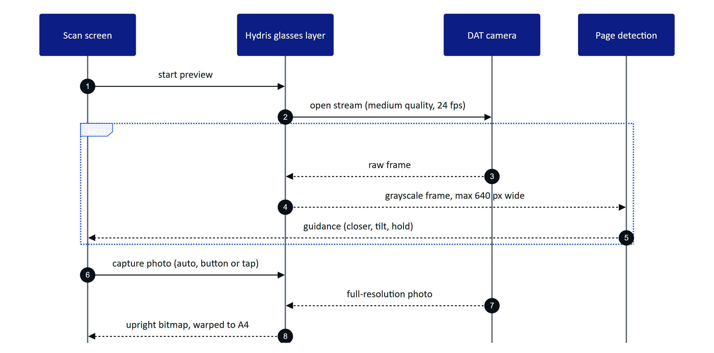
Figure 3. Guided capture from the glasses camera
Preview frames are processed in memory for framing only; Hydris reads the luma plane and never stores or uploads frames. The photo is taken only on an active stream, decoded (bitmap or HEIC), rotated upright from EXIF, then flattened to an A4 page of 1654 x 2339 pixels. Images leave the phone only when the operator taps "Send for verification".

Capture button and speech
A short press of the capture button starts a glasses scan from the Scan menu or review, and takes the photo while framing; elsewhere it is ignored. Speech is always on while wanted: transcripts arrive as text, Hydris restarts listening after silence and ignores transcripts while its own answer is playing. Answers are spoken by the phone's text-to-speech and play on the glasses when they are the Bluetooth audio output. Hydris receives transcripts, never audio, and sends only the question text to the assistant.

1.7 Two integration routes
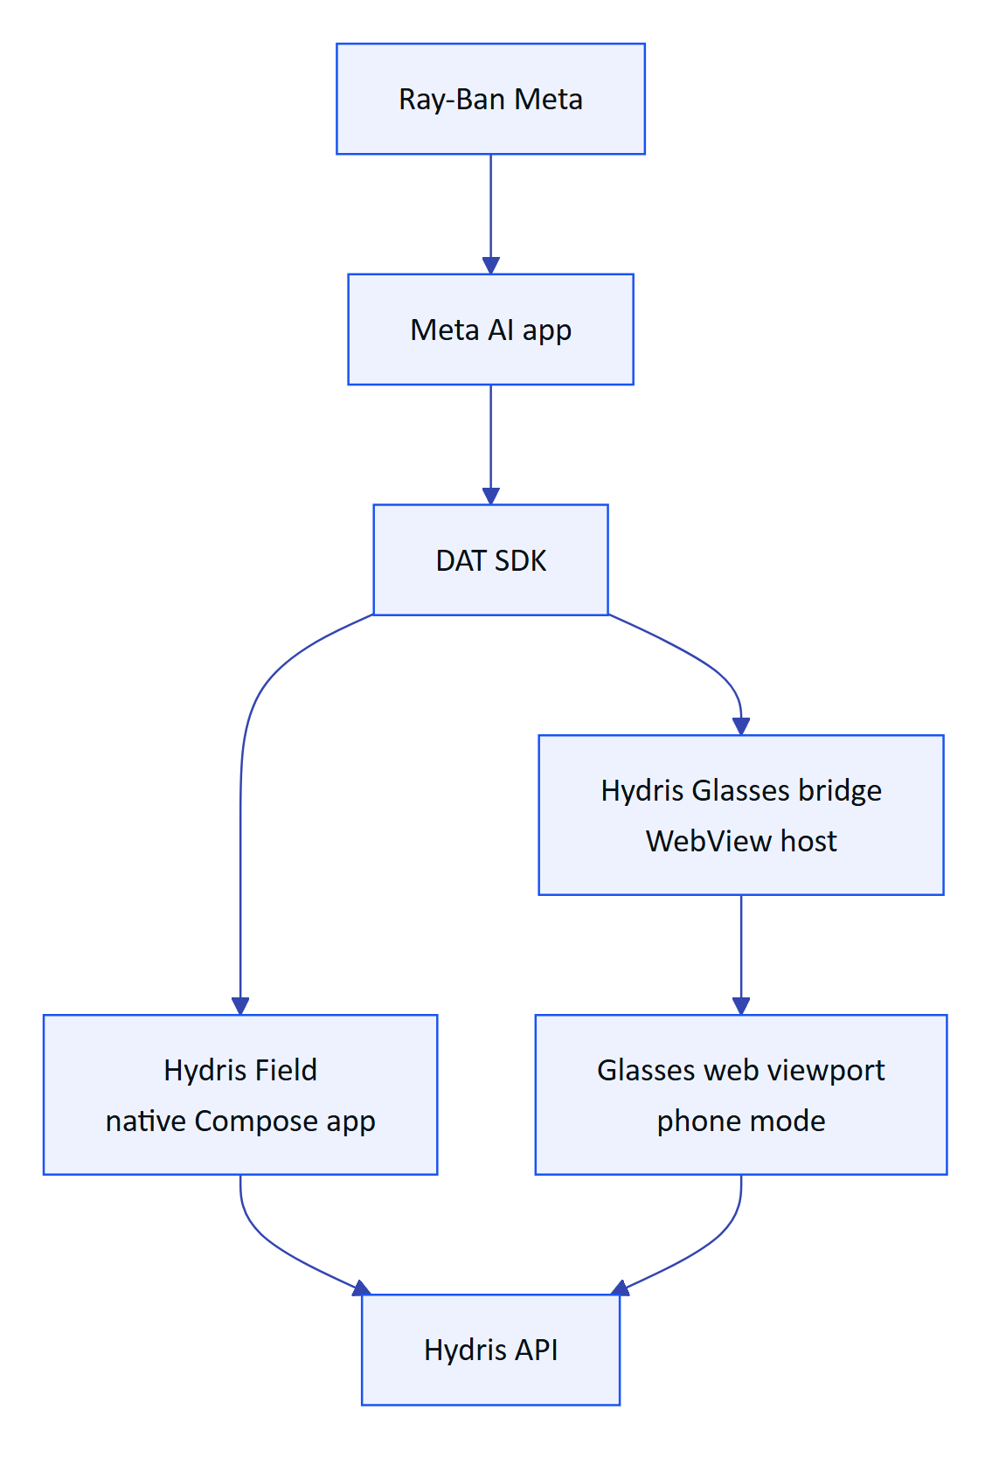
Figure 4. Native app and WebView bridge share DAT and the backend
Table 4. The two routes compared
Aspect | Hydris Field (native) | Glasses bridge (WebView)
UI | Native Compose screens | The /glasses web viewport in phone mode
How DAT reaches the UI | Kotlin state flows | HydrisNative JavaScript interface and page callbacks
Registration as a Hydris device | Self-approved by the signed-in user | Code and QR, approved by a supervisor
"Hey Meta, start Hydris" | Planned | Built
Intended use | Pilot runtime | Web viewport and development comparison; not for general distribution

The bridge forwards one JPEG preview frame per 120 ms and full photos at quality 92 to the page; the page gives up on a photo after 20 s. The same page also supports an injected promise API for iOS hosts and a postMessage protocol for any embedding host.
WARNING
Bridge hardening is Planned: the WebView grants every page permission request and does not restrict navigation away from the Hydris site. Restrict navigation to the Hydris origin before distributing the bridge outside the team.

1.8 Registering glasses as a Hydris device
The Meta AI app pairs the glasses to the phone; Hydris pairing makes them a managed device: assigned to a person and a site, visible to supervisors, revocable, and credited for the scans they capture (FR-057). In the native app the phone plays both roles of the device flow at once.
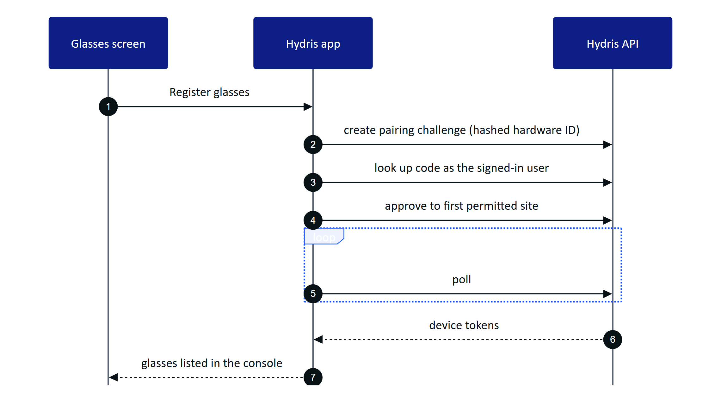
Figure 5. Self-approved registration in the native app
The hardware ID is rbm- plus a SHA-256 digest of the DAT device identifier, so the raw Meta identifier never leaves the phone and re-registering reuses the same console record. Glasses registered in another organization must be revoked there first (device_owned_elsewhere).
NOTE
The same glasses paired through both routes produce two device records, because the hardware IDs differ. Pilots should use one runtime per pair. The native app assigns the glasses to the first site the user can see; a site picker is Planned before multi-site pilots.

1.9 Setup guide
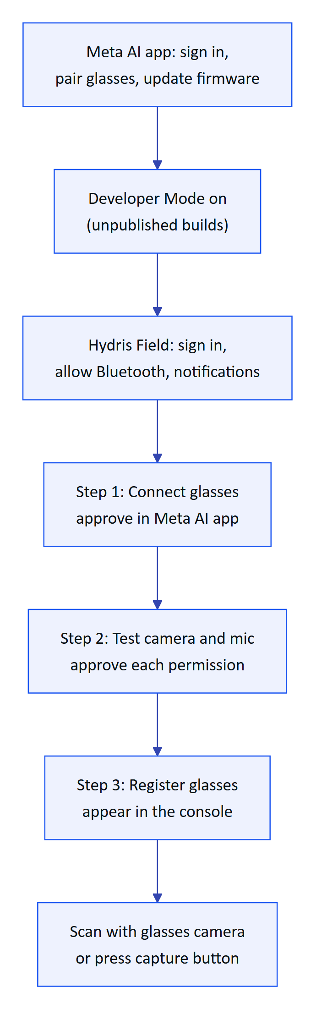
Figure 6. First-time setup for a pilot operator
Developer Mode is turned on in the Meta AI app under Settings, App Info, by tapping the app version five times. Speech, Inputs and Voice Invocations are experimental in DAT and must be enabled for the app in Meta's Wearables Developer Center; Hydris treats them as optional and keeps the phone fallbacks. Developer Mode builds use placeholder DAT credentials; production builds use the values issued by the Developer Center.

1.10 Troubleshooting
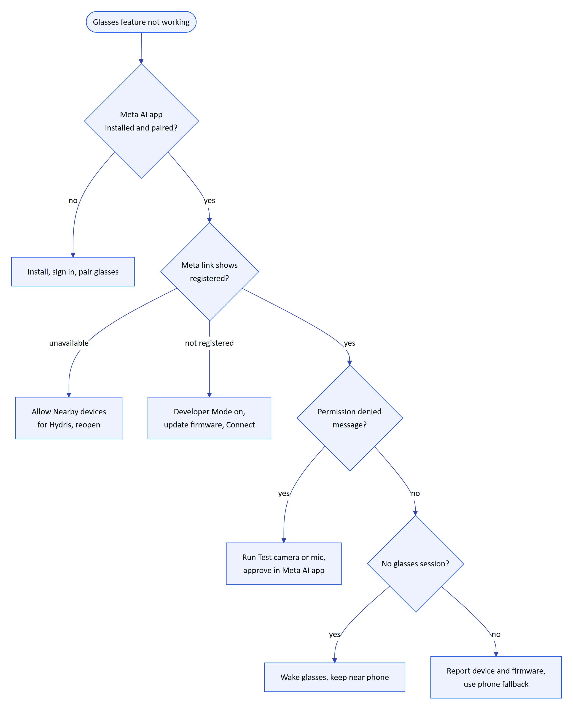
Figure 7. Troubleshooting decision tree
Table 5. Other common symptoms
Symptom | Fix
Capture button ignored | Enable Inputs in the Developer Center; open Scan
Answers play on the phone speaker | Reconnect audio to the glasses in Android Bluetooth settings
Preview black or garbled | Report device and firmware; use the phone camera meanwhile
"Your account has no site to assign the glasses to" | Ask an admin for site access
device_owned_elsewhere | Revoke the glasses in the other organization

1.11 Requirements
Table 6. Ray-Ban Meta requirements (IDs from the PRD)
ID | Requirement | Pri | Status
FR-055 | Glasses camera through DAT: preview stream and full-resolution photo | M | Partial (not on hardware)
FR-056 | Capture button takes the photo or starts a scan | S | Partial (not on hardware)
FR-057 | Android app registers the glasses as a Hydris device | M | Partial (not on hardware)
FR-074 | Glasses microphone with phone fallback; answers on the speakers | M | Partial (phone path Built)
FR-077 | "Hey Meta, start Hydris" opens the assistant | C | Partial (bridge only)
NFR-015 | Camera only on explicit intent; no continuous recording | M | Built
NFR-028 | 4-hour shift on Ray-Ban Meta with up to 20 scans | S | Planned (measure)
NFR-029 | Android 12 or later | M | Built

1.12 Success metrics
Table 7. Timing targets for the first hardware run (targets, not measured)
Path | Target
First preview frame after opening the glasses scan | Under 3 s with an existing session
Preview rate reaching detection | 8 to 10 frames per second
Photo returned after capture | Under 4 s
Speech restart gap after silence | Under 1 s
Battery | 4-hour shift with up to 20 scans (NFR-028)

1.13 Limitations and publishing constraints
- Not yet run on hardware. Preview stride inference, capture press decoding and speech restart are unverified.
- The DAT camera stream is not stopped when the preview ends, only when the session ends; battery and capture LED impact to be checked.
- Low-resolution preview. Frames cross the wireless link, so detection runs on small frames; the photo is full resolution.
- Publishing. Public publishing of DAT apps is not open yet (Meta FAQ); pilots rely on Developer Mode and Developer Center release channels. Full Developer Center access is limited to countries where Meta AI glasses are supported.
- Testing. Hydris has no automated DAT tests yet, and Meta's Mock Device Kit does not support display glasses.
- Privacy. Meta glasses show a capture LED that Hydris cannot control; whether it is lit during preview streaming is to be confirmed. Pilot sites should brief staff and mark scan points.

1.14 Hardware acceptance status
Table 8. Hardware acceptance tests (none run yet)
ID | Test | Status
GLS-T01, T02 | Connect with and without Developer Mode | Not run
GLS-T03 to T06 | Camera permission, guided A4 scan, leaving scan, photo orientation | Not run
GLS-T07, T08 | Capture button short and long press | Not run
GLS-T09, T10 | Ten minutes of Hey Hydris, answers on the speakers | Not run
GLS-T11 to T13 | Register, revoke then upload, glasses off mid-session | Not run
GLS-T14 | Repeat camera and voice tests through the bridge | Not run
GLS-T15 | Battery over a simulated four-hour shift | Not run

Next steps, in order: the first run on Ray-Ban Meta Gen 2 with this checklist, stopping the DAT stream when the scan screen closes, and bridge hardening (Q4 2026); Oakley Meta validation, Voice Invocations in the native app and DAT mock-device tests (Q1 2027); a Developer Center release channel pilot and a site picker for registration (Q2 2027). Using the Meta Ray-Ban Display screen remains Planned and unverified.

